Surname: DITLHOTLHOLE Intials:K.J.D.
Student ID: 202002023

CSI223-Lab Exercise 4: Positional Parameters, Iterations and File String Manipulation

2. $#It returns the number of the parameters
$0It returns the name of the script that is running and location of that script in the file.
$*it gives every single word containing all the parameters passed to the script.
$@gives an array of words containing all the parameters passed to the script
3. The output is
15
The for loop adds all the numbers 1, 2, 3, 4 and 5 to return 15
4. The output is
I am in /csusers/ugrad/dit02023/csi223/ex4 and it contains
iftrue.sh number3.sh

5.
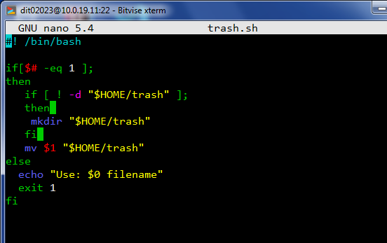
6.


